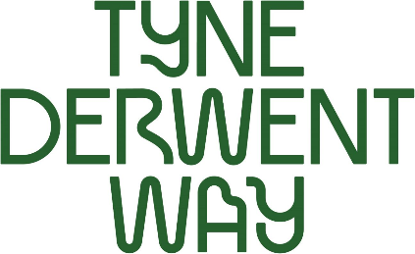 

**Volunteer Role**: Dunston Staiths Steward | Meet and Greet

**Location**: Dunston Staiths

**Availability**: Flexible

**To apply**: Follow this link to complete our online form: [Get involved: Tyne Derwent Way](https://www.tynederwentway.co.uk/article/27362/Get-involved)

**For more information or an informal chat**: E: [stewart.turnbull@nationaltrust.org.uk](mailto:stewart.turnbull@nationaltrust.org.uk)

or call/text: 07880 278 216

Dunston Staiths, on the river Tyne, is believed to be the largest timber structure in Europe. It is classified as a scheduled monument. Grade II listed and is owned by the registered charity Tyne and Wear Building Preservation Trust (TWBPT).

Opened in 1893 by the North East Railway Company, it was built to allow large quantities of coal arriving by rail from the Durham Coalfields to be loaded directly onto waiting colliers (coal ships) ready for the onward journey to customers in London and abroad. At the coal industry's peak, around 5.5 million tons of coal were moved this way each year.

Dunston Staiths is now an iconic part of the Tyne Derwent Way. A green corridor that runs from St Mary’s Heritage Centre in urban Gateshead, along the banks of the rivers Tyne and Derwent, to the National Trust’s Gibside estate.

Dunston Staiths has been closed for the last few years, but it is once again open to the public. This includes general opening as well as hosting special events, such as Gateshead International Festival of Theatre [GIFT] and The Late Shows.

This is an exciting time to get involved. We are looking for friendly and enthusiastic volunteers to help us with open days, steward events, and support activities.

Whether you can volunteer occasionally for a couple of hours or would like to sign up to more regular shifts, we’d love to hear from you.

**Role and responsibilities include**

* Opening and setting up, clearing up and closing at the end of the session, with full training and checklist provided
* Providing meet-and-greet/stewardship for our open days and events programme
* Processing payments and donations. Full training provided
* Keeping records of visitor numbers
* Become familiar with Dunston Staiths’ history and heritage
* Answering visitors questions
* Keep up-to-date with current activities and services on offer

**Knowledge, skills and experience**

* Warm, open and friendly nature
* Confident when talking to members of the public visiting the Staiths
* Ability to work well within a team
* Confidence to work on own initiative
* Processing chip and pin/cash payments. Full training provided

**Check requirements**

All volunteers will be asked to provide two references from people who know you well enough to answer a few questions about you. They do not have to be professional references or previous employers. Please contact Stewart Turnbull, our Volunteer Manager, if you have any questions, concerns or worries about this.

**Learning and development**

* Complete Dunston Staiths Volunteer Induction, training and support sessions as required
* Attend scheduled volunteer meetings (where appropriate)

**General Information**

* We always act in accordance with the Tyne and Wear Building Preservation Trust’s Code of Conduct and H&S policy
* Volunteers will be reimbursed for travel according to our Volunteer Policy

**What is in it for you?**

As well as helping to support the upkeep and preservation of one of our locally loved heritage landmarks, set along the Tyne Derwent Way, this is a great opportunity to meet people from a wide variety of backgrounds and to gain experience of working as part of a small, dedicated team.

Volunteers will gain valuable experience in heritage, stewardship and events

organisation, all of which could enhance your CV.

As part of our promise to all our volunteers, you will receive a volunteer induction as well as role-specific training and/or support to help you carry out your volunteer role confidently and competently. You will have the option to contribute to our volunteer and supporter’s newsletters.

Find out more about the Tyne Derwent Way and the history, culture and nature along Gateshead’s riversides here: [www.tynederwentway.co.uk](http://www.tynederwentway.co.uk)